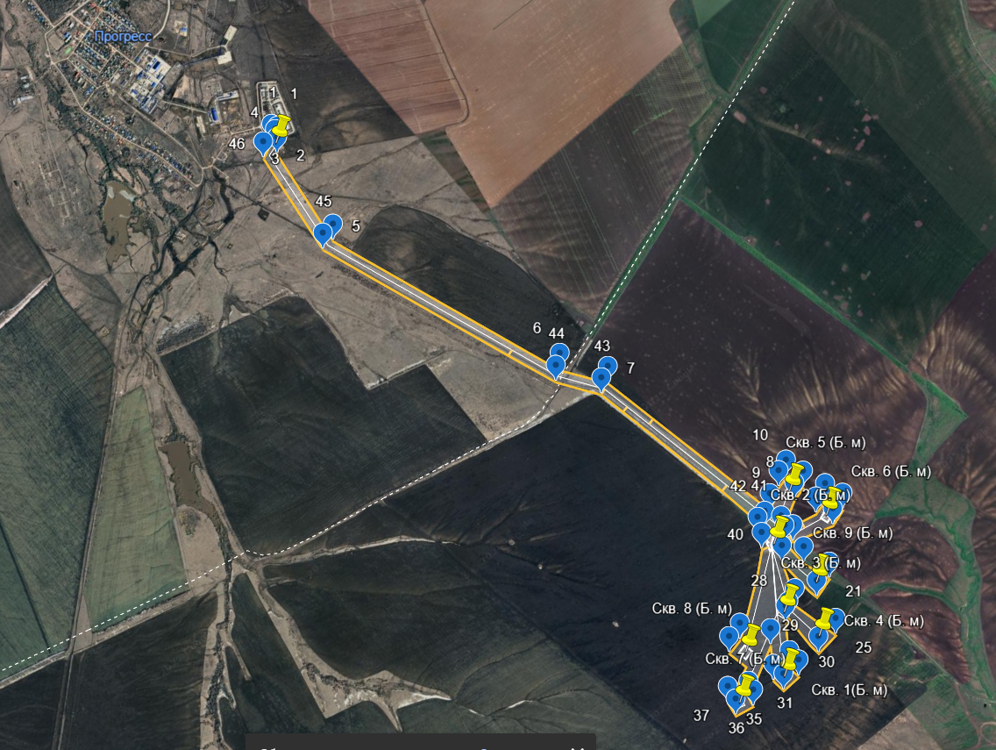 Ситуационный план участка работ

Географические координаты угловых точек участка работ в формате WGS84

|  |  |  |
| --- | --- | --- |
| № точки | Северная широта | Восточная долгота |
| 1 | 52°30'22" | N 49°02'07"E |
| 2 | 52°30'20" | N 49°02'08"E |
| 3 | 52°30'20" | N 49°02'07"E |
| 4 | 52°30'18" | N 49°02'05"E |
| 5 | 52°29'54" | N 49°02'00"E |
| 6 | 52°28'55" | N 49°02'34"E |
| 7 | 52°28'45" | N 49°02'45"E |
| 8 | 52°27'57" | N 49°03'01"E |
| 9 | 52°28'00" | N 49°03'09"E |
| 10 | 52°28'01" | N 49°03'14"E |
| 11 | 52°27'56" | N 49°03'17"E |
| 12 | 52°27'55" | N 49°03'11"E |
| 13 | 52°27'51" | N 49°02'59"E |
| 14 | 52°27'49" | N 49°03'14"E |
| 15 | 52°27'50" | N 49°03'20"E |
| 16 | 52°27'46" | N 49°03'23"E |
| 17 | 52°27'44" | N 49°03'16"E |
| 18 | 52°27'48" | N 49°03'00"E |
| 19 | 52°27'49" | N 49°02'57"E |
| 20 | 52°27'42" | N 49°02'57"E |
| 21 | 52°27'35" | N 49°03'01"E |
| 22 | 52°27'34" | N 49°02'53"E |
| 23 | 52°27'46" | N 49°02'51"E |
| 24 | 52°27'36" | N 49°02'44"E |
| 25 | 52°27'24" | N 49°02'49"E |
| 26 | 52°27'24" | N 49°02'39"E |
| 27 | 52°27'35" | N 49°02'39"E |
| 28 | 52°27'34" | N 49°02'37"E |
| 29 | 52°27'26" | N 49°02'27"E |
| 30 | 52°27'23" | N 49°02'27"E |
| 31 | 52°27'22" | N 49°02'19"E |
| 32 | 52°27'26" | N 49°02'18"E |
| 33 | 52°27'33" | N 49°02'27"E |
| 34 | 52°27'27" | N 49°02'07"E |
| 35 | 52°27'24" | N 49°02'06"E |
| 36 | 52°27'25" | N 49°01'58"E |
| 37 | 52°27'29" | N 49°01'59"E |
| 38 | 52°27'38" | N 49°02'12"E |
| 39 | 52°27'38" | N 49°02'19"E |
| 40 | 52°27'51" | N 49°02'49"E |
| 41 | 52°27'55" | N 49°02'51"E |
| 42 | 52°27'55" | N 49°02'55"E |
| 43 | 52°28'44" | N 49°02'40"E |
| 44 | 52°28'54" | N 49°02'30"E |
| 45 | 52°29'54" | N 49°01'54"E |
| 46 | 52°30'20" | N 49°02'00"E |